PAT batch 23 Task 10 :

**Question number 1: Installing requirements document using pip command**

Installing virtua environment using PIP command “pip install pipenv”

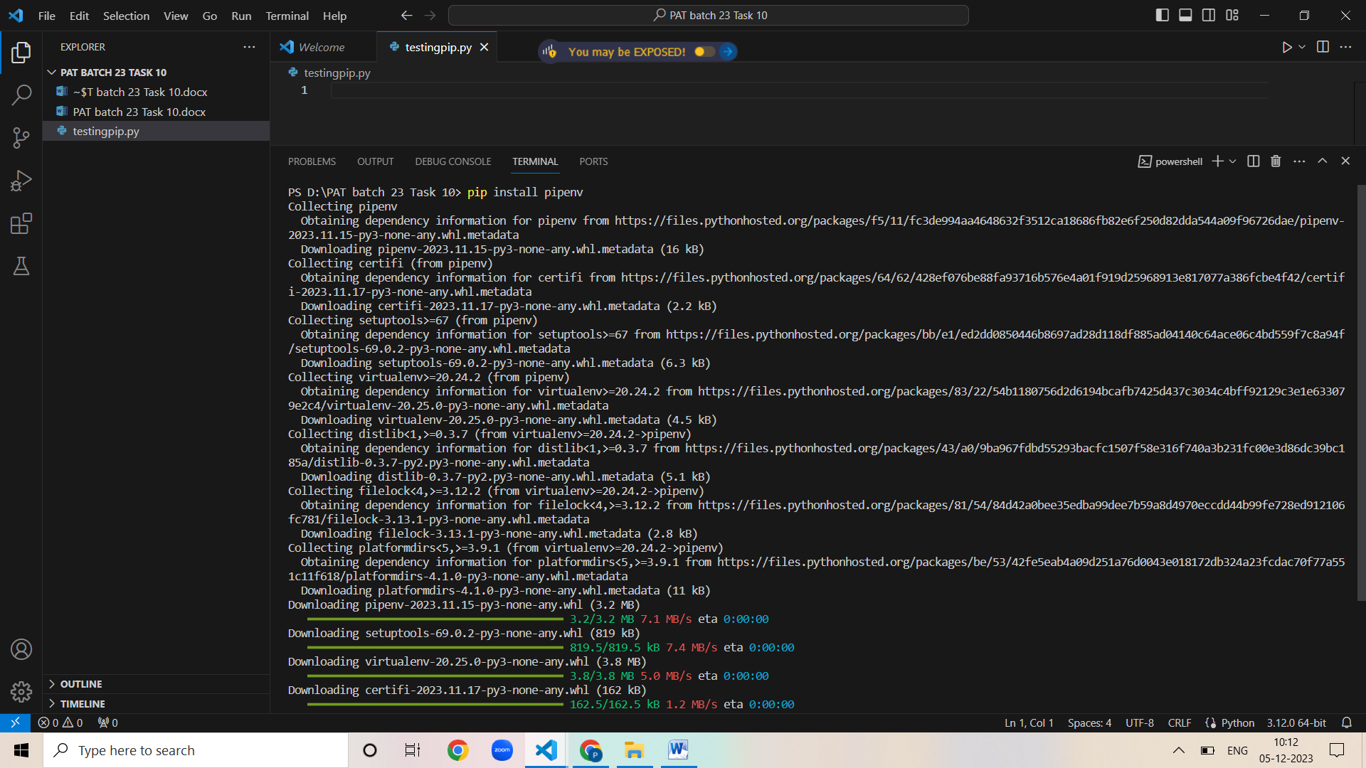

Installing packages using the command “ pipenv install mypackage”

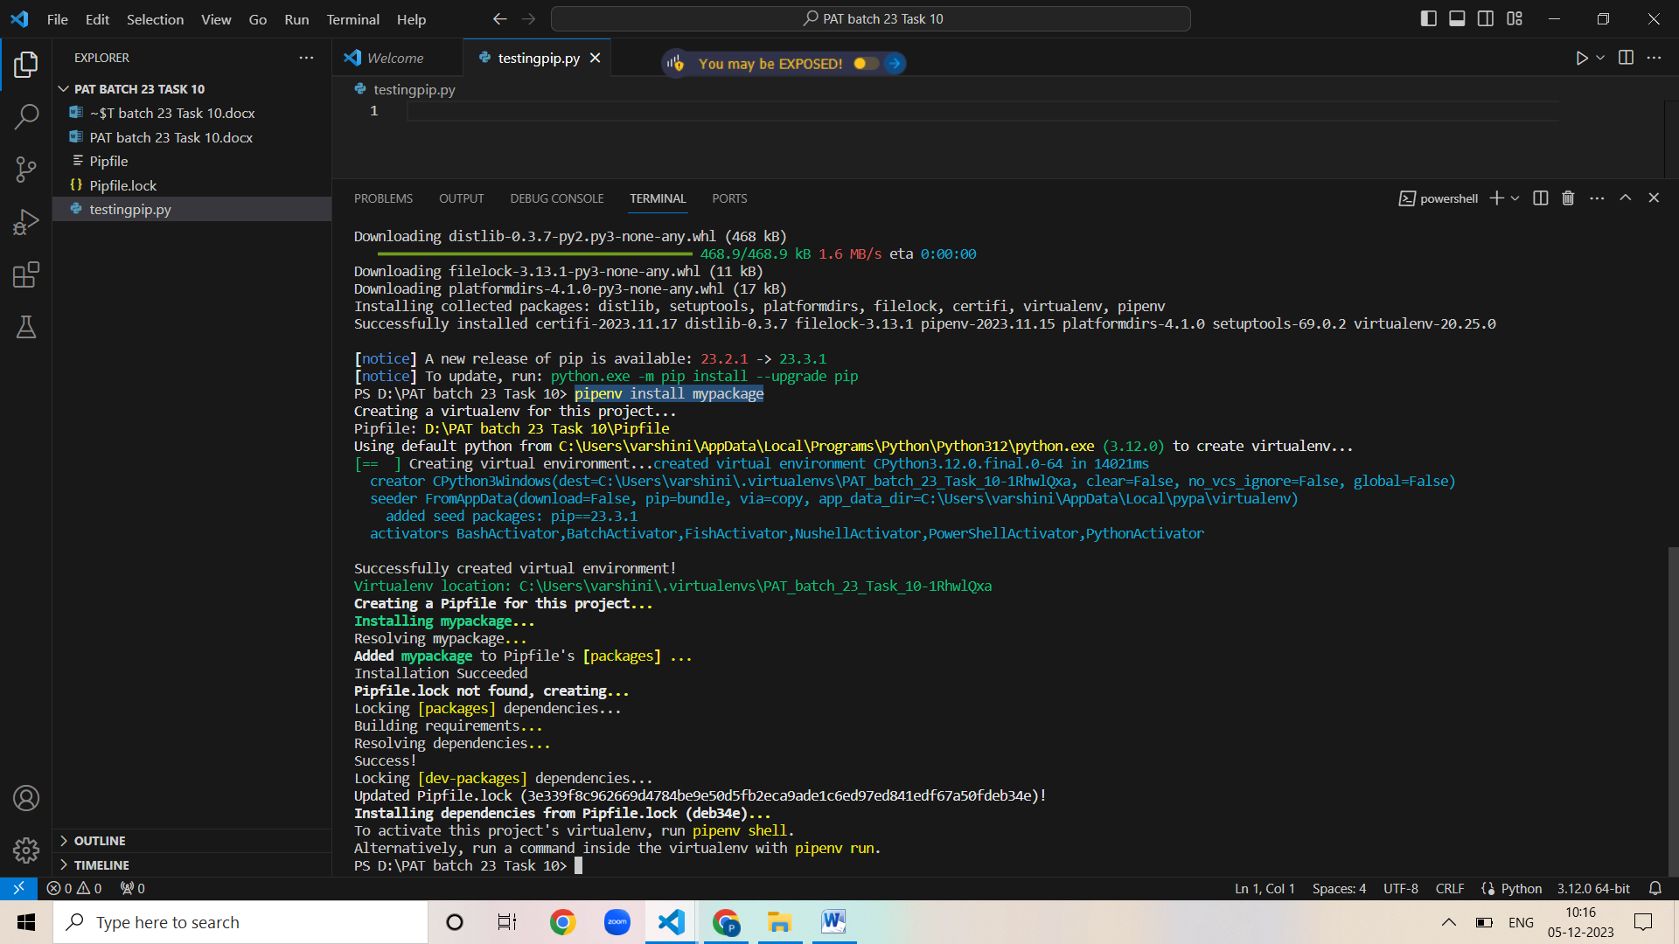

Initializing the virtual environment “pipenv shell”

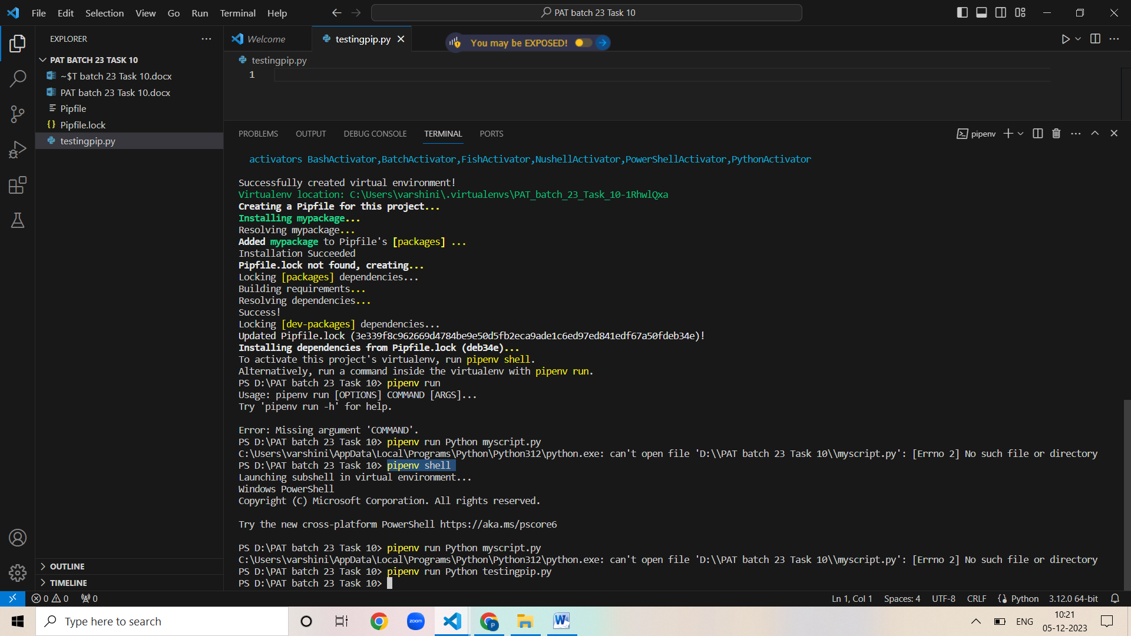

Installing requirements.txt without virtual env

Using command – pip install pipreqs

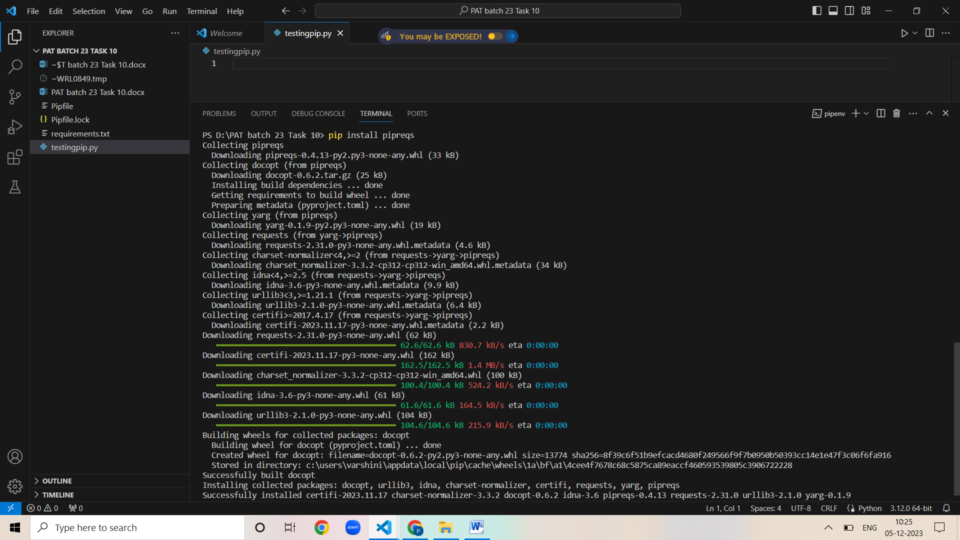

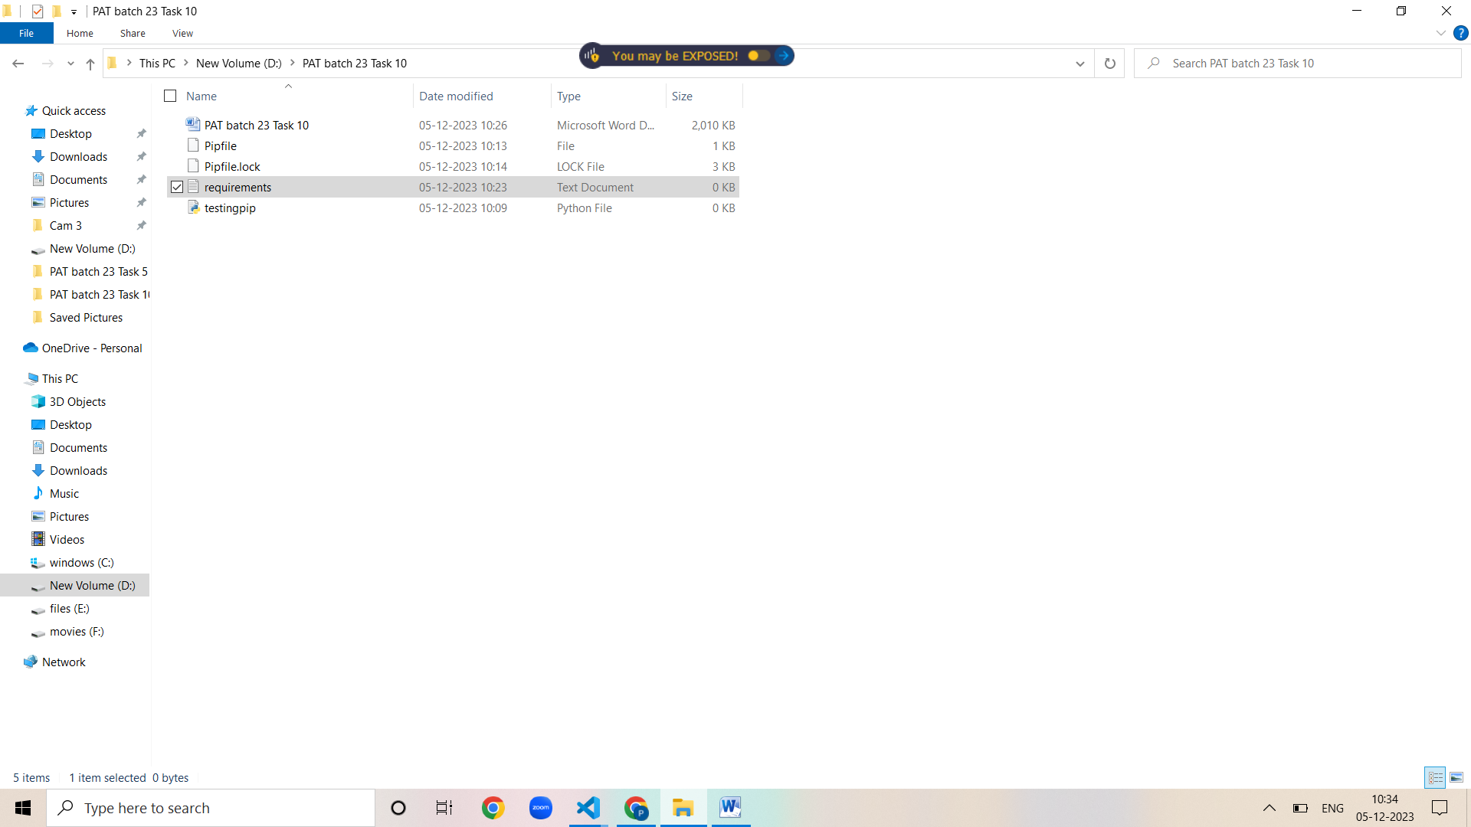

==================================================================================

**Question number 2.Installing python flask module less than 2.0 version using the command**

“Pip install flask<2.0”

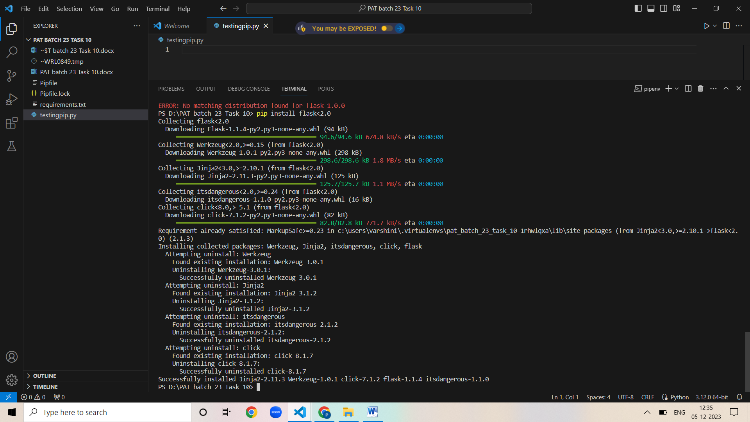

Checking the version installed using the comment “pip show flask”

